WAN Technologies
Easy Notes for Beginners
A simple, easy-to-understand guide to Wide Area Network technologies

What is a WAN?
A WAN means “Wide Area Network.” It is a big network that joins computers which are far away from each other — maybe in different cities or even different countries. Think of it like a very long road that connects many small towns (small networks) into one big country (one big network).
There are many ways to build this long road. Each way is called a “technology.” This note explains the most common WAN technologies in simple words: X.25, Frame Relay, ATM, DSL, Cable Modems, Point-to-Point Microwave Link, and VSAT.

1. X.25
X.25 is one of the oldest ways to send data over long distances. It uses a network of special machines called “X.25 switches” to pass data from one place to another, like passing a ball from hand to hand until it reaches the goal.

Main Points
- It is a packet-switched network. This means data is cut into small pieces, called packets, before sending.
- It is connection oriented. This means a path is fixed first, and then data travels on that path. This fixed path is called a Virtual Circuit.
- Every computer (end node) in the network has its own X.25 address, just like every house has its own address.
- The speed is quite slow: about 2.4 to 9.6 kbps.
- Normal IP networks can join an X.25 network using a special connector called an IP-X.25 router.
In simple words: X.25 sends data in small pieces, on a fixed path, at a slow speed.

X.25 and Virtual Circuits — Picture
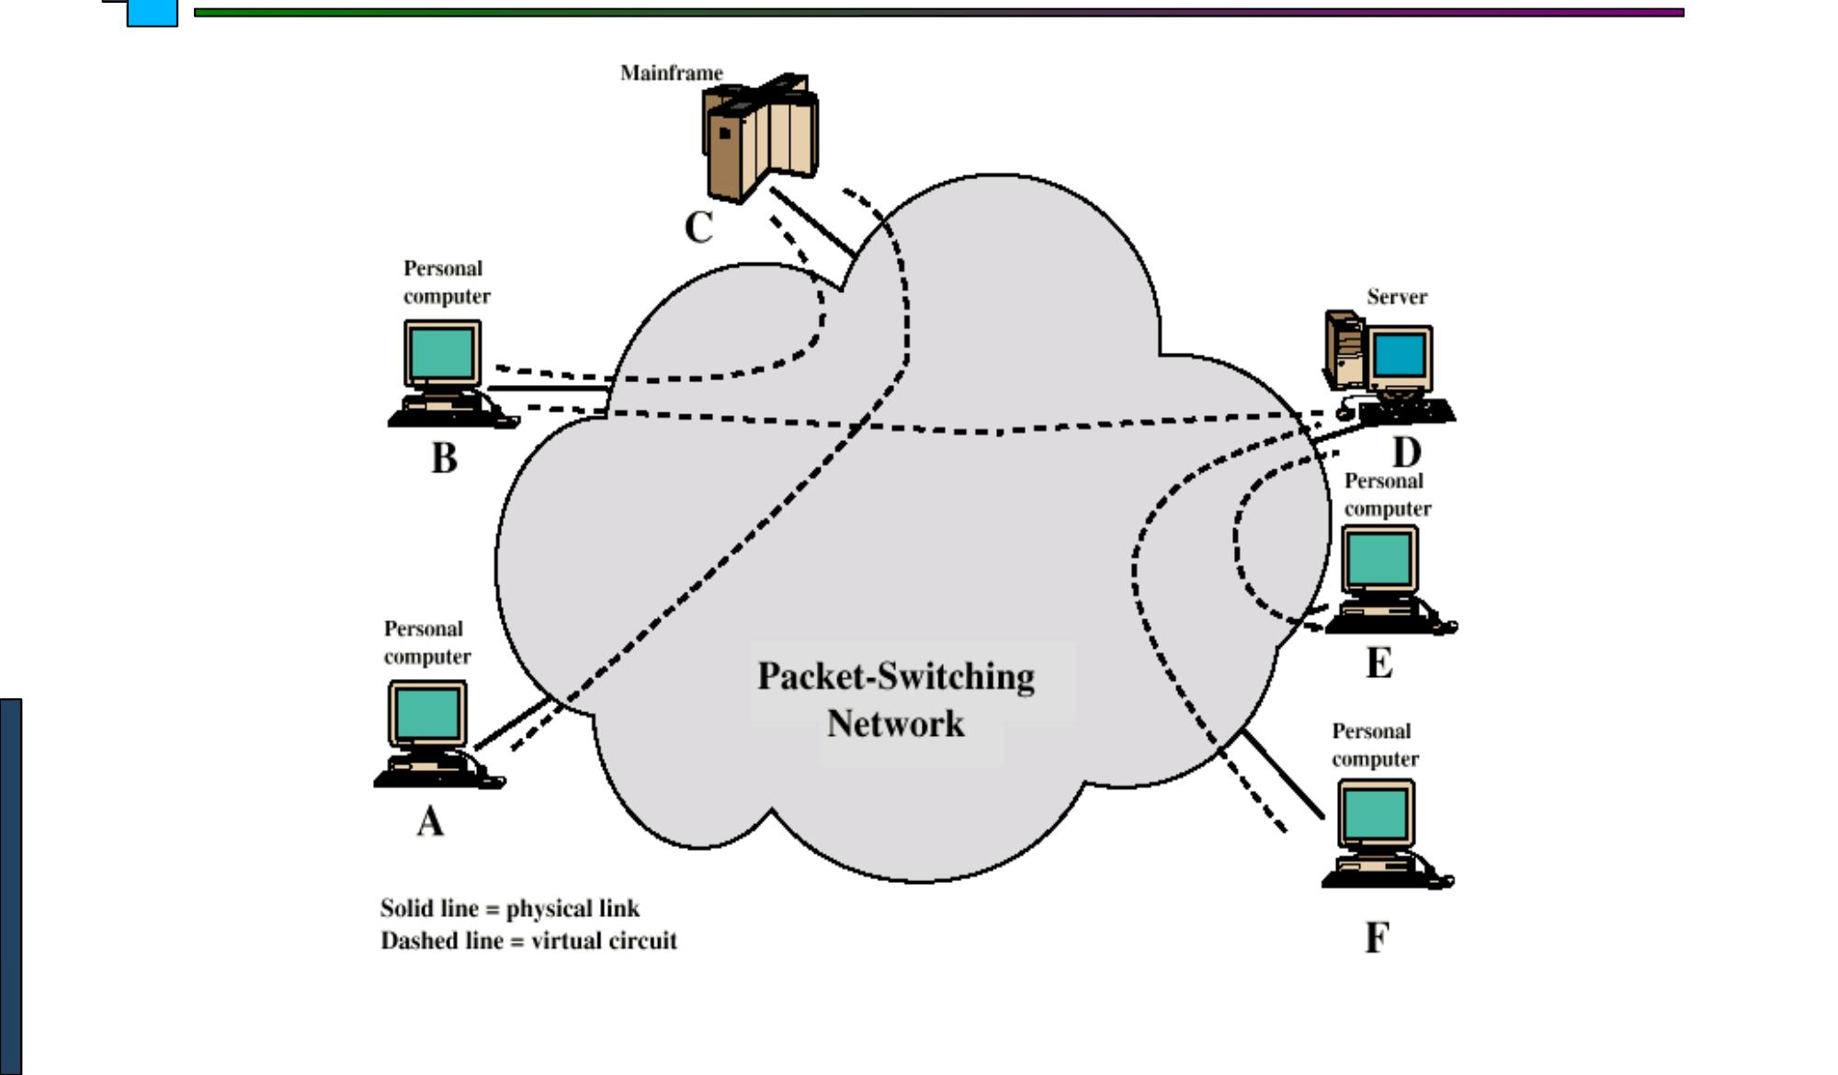
Computers A to F send data through the Packet-Switching Network. Solid lines are real wires. Dashed lines are the virtual (imaginary) paths the data follows.

2. Frame Relay
Frame Relay was made after X.25, to fix its problems. It is faster and simpler. It was made before ATM (the next technology in this note).

Main Points
- It was designed to work better and faster than X.25.
- Call control (setting up the connection) is done separately from the actual data path.
- It does not check for errors or control the flow at every hop (every stop along the way). This makes it faster.
- If error and flow control is needed, it is handled end-to-end, meaning only at the start and the end, by a higher layer — not at every stop in between.
- One data frame is sent from the sender to the receiver, and one ACK (acknowledgement, meaning “got it!”) is sent back by the higher layer.
- It has two types of Virtual Circuits:
  - Permanent Virtual Circuits (PVCs) — a path that always stays ready, like a fixed road.
  - Switched Virtual Circuits (SVCs) — a path that is made only when needed, and removed after use.
In simple words: Frame Relay is a quicker, simpler version of X.25, with two kinds of paths: always-on (PVC) and made-when-needed (SVC).

3. ATM (Asynchronous Transfer Mode)
ATM sends data in very small, same-size pieces called cells. Because every cell is the same size, the network can handle them very smoothly and quickly, like sending toy blocks that are all the same shape.

Main Points
- Each cell is exactly 53 bytes: 5 bytes are the header (the address label) and 48 bytes are the payload (the real data).
- It is a connection-oriented protocol, so a Virtual Circuit is set up first, before any data is sent.
- It works well in both LANs (small local networks) and WANs (big long-distance networks).
- It can grow very big — it has almost unlimited scalability.
- It can promise a certain quality of service, meaning it can guarantee smooth and steady delivery for things like video calls.
In simple words: ATM cuts data into small, equal-size cells (53 bytes each) and sends them on a fixed path, giving smooth and reliable delivery.

4. Digital Subscriber Line (DSL)
DSL lets you use the internet through the same wire used for your home telephone. It is called “always-on” because you do not need to dial a number every time — the internet connection is always ready.

Main Points
- It uses the ordinary telephone line.
- It is always-on — no need to dial up.
- DSL depends a lot on noise (disturbance) in the line. So, the user cannot be more than about 5.5 kilometers (2–3 miles) away from the DSL exchange (the telephone company’s office).
- The service can be symmetric (same speed for sending and receiving) or asymmetric (receiving is faster than sending).

Types of DSL
- ADSL — Asymmetric DSL (downloading is faster than uploading).
- HDSL — High Data Rate DSL.
- SDSL — Symmetric DSL (same speed both ways).
- VDSL — Very High Data Rate DSL.
In simple words: DSL uses your telephone wire to give always-on internet. It comes in different types depending on speed and whether upload and download speeds are equal.

ADSL — How it Looks
ADSL is the most common type of DSL. At the telephone company’s office, a splitter and a machine called DSLAM sends the internet signal. At your home, another splitter separates the telephone signal and the internet signal, and an ADSL modem connects your computer to the internet.
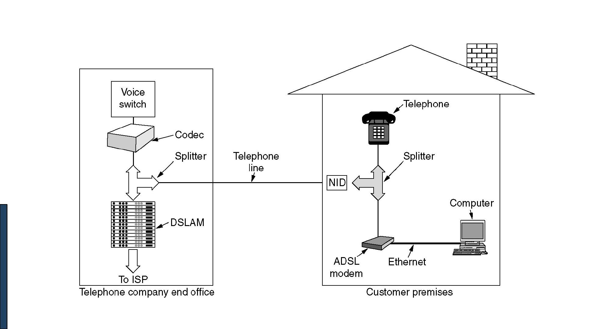
On the left is the telephone company’s office. On the right is the customer’s home, where the ADSL modem connects the computer through Ethernet.

5. Cable Modems
A cable modem lets your computer use the internet through the same cable wire used for cable TV. So one wire can carry both your TV shows and your internet, at the same time.

Main Points
- It connects your computer to the cable company’s network using the same coaxial cable that carries TV (CATV) signals.
- At home, you use a Cable Modem. At the cable company’s office (called the Head End), they use a CMTS (Cable Modem Termination System).

Characteristics
- It is a shared bandwidth technology, meaning many homes share the same line.
- Downstream speed (data coming to you): 10 Mbps to 30 Mbps.
- Upstream speed (data going from you): 128 Kbps to 3 Mbps.
- Maximum distance from the provider to the customer: 30 miles.
In simple words: A cable modem shares your TV wire to also give you internet, with fast download speed and a slower upload speed.
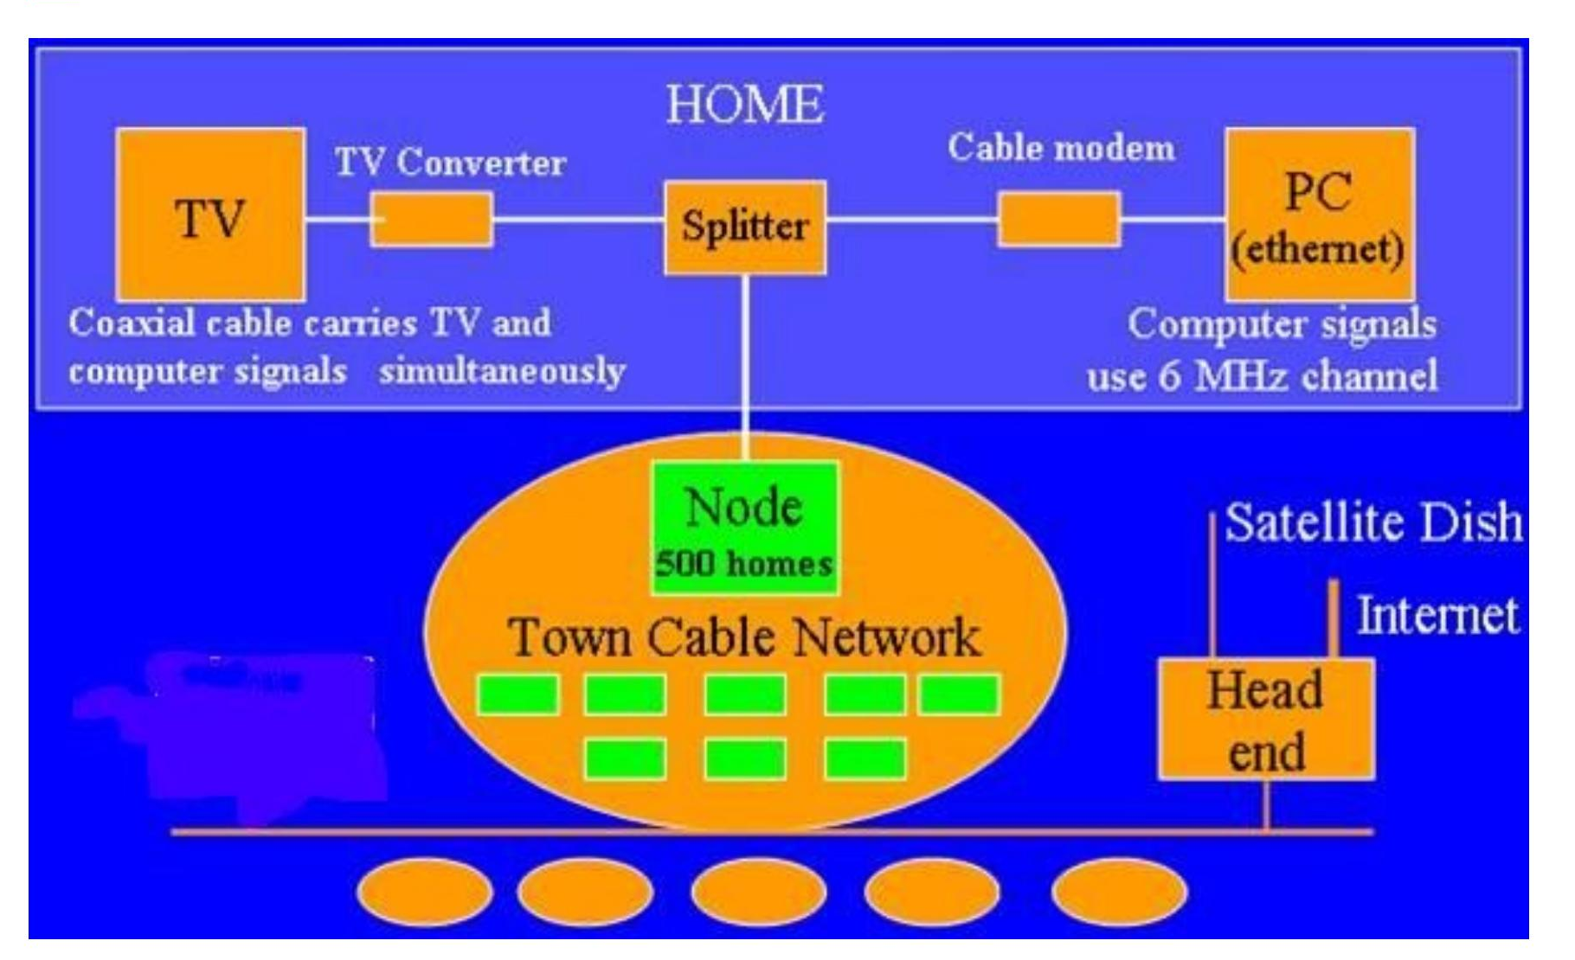
At home, a splitter sends the signal to both the TV and the PC. All homes connect to a Node, which connects to the Town Cable Network and then to the Head End, which connects to the Internet.

6. Point-to-Point Microwave Link
This technology sends data through the air using radio waves, instead of using wires. It works like sending a message using a flashlight beam pointed straight at a friend — but here, the “light” is a microwave signal.

How it Looks
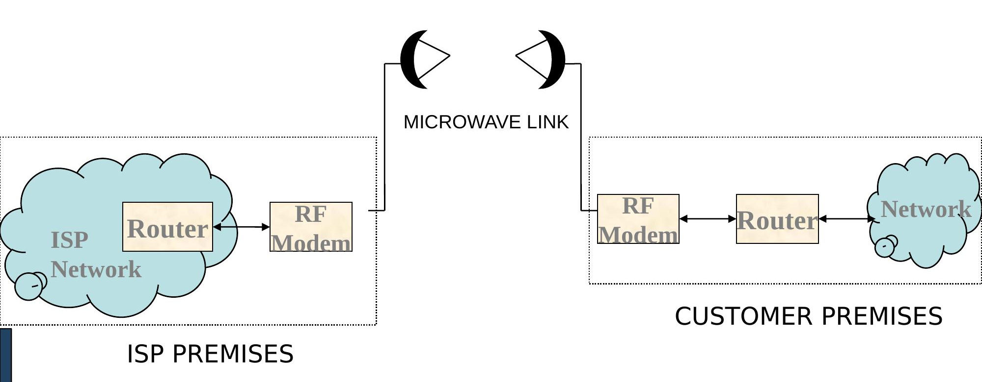
The ISP’s network and the customer’s network each have a Router and an RF Modem. The two RF Modems talk to each other through the microwave link in the air.

How it Works
- Transmitter and Receiver: Each end of the link has a radio unit and a dish-shaped (parabolic) antenna.
- Microwave Beam: The transmitter sends a tightly focused microwave beam straight to the receiving antenna at the other end.
- Line of Sight: The two antennas must be able to “see” each other clearly, with nothing blocking the view, for a strong and steady signal.
- Data Transmission: Because the beams are narrow and focused, many microwave links nearby can use the same frequency without disturbing each other.

Key Advantages
- Speed and Reliability: It gives high-speed data transfer, almost as good as fiber optic cables, with low delay (latency).
- Cost-Effectiveness: It is cheaper and quicker to set up than laying physical fiber cables, especially in hard-to-reach places.
- Flexibility: Networks using this technology can be set up fast for many different needs.
- High Capacity: It can carry large amounts of data, including voice, video, and internet traffic.

Technical Notes
- It typically uses the 80–100 MHz band or the 5 GHz radio link band.
- 2.4 GHz Wi-Fi links are also becoming popular for this purpose.
- It always needs a clear line of sight between the two ends.
In simple words: This technology beams data through the air between two antennas that can see each other, and works almost as fast as fiber cable.

7. VSAT (Very Small Aperture Terminal)
VSAT lets two faraway places talk to each other using a satellite in the sky, instead of long cables on the ground. A satellite dish sends the signal up to the satellite, and the satellite sends it back down to the other side.

Uplink and Downlink
- Each satellite sends and receives over two bands.
- Uplink: signal travels from the earth up to the satellite.
- Downlink: signal travels from the satellite down to the earth.

Satellite Frequency Bands
Band | Downlink | Uplink
C | 3.7 – 4.2 GHz | 5.925 – 6.425 GHz
Ku | 11.7 – 12.2 GHz | 14 – 14.5 GHz

- Ku-band networks are mostly used in Europe and North America, and they use smaller VSAT antennas.
- C-band is used a lot in Asia, Africa, and Latin America, and it needs bigger antennas.

VSAT Broadcast — Picture
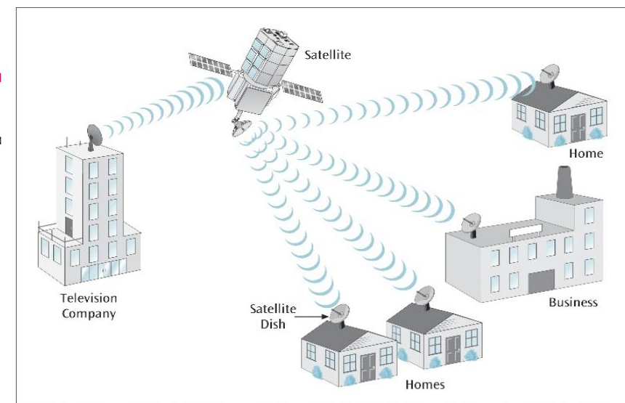
A satellite sends signals down to homes, a business, and receives from a television company — all using small satellite dishes.

How VSAT Works
- Two-Way Communication: VSAT lets remote places send and receive data with the satellite network, both ways.
- Satellite Connection: VSATs usually use geosynchronous or geostationary satellites, which stay in a fixed spot in the sky, to pass signals between earth stations.
- Network Topologies:
  - Star Topology: Remote VSAT terminals talk to one main earth station, called a hub.
  - Mesh Topology: VSAT terminals can talk directly to each other, without needing a hub.
- Components: The main parts include the dish antenna, the Block Up Converter (BUC, which sends the signal up), and the Low Noise Block down converter (LNB, which receives the signal).
- If two terminals want to talk, they send their message to the satellite. The satellite sends it to the Hub, and the Hub then sends the message back out through the satellite to the other terminal.
- Typical bandwidth offered: 9.6 / 19.2 / 32 / 64 / 128 / 256 / 512 Kbps.
- The operating modes are TDM/TDMA, SCPC, PAMA, and DAMA.

VSAT through a Hub — Picture
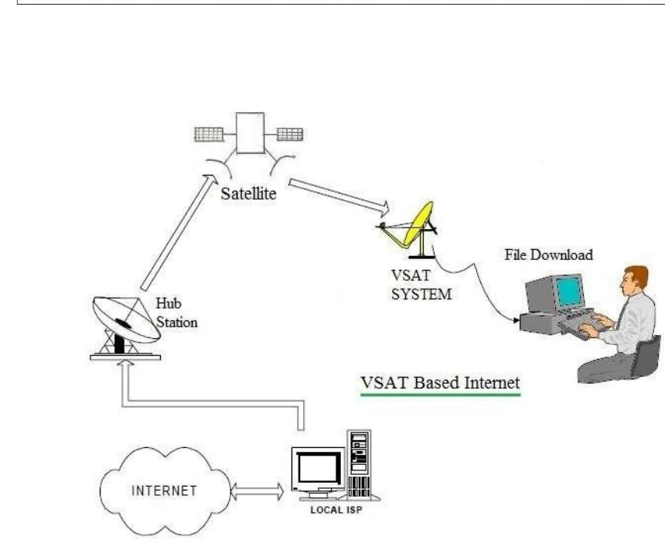
The Hub Station sends and receives through the satellite. The VSAT system at the far end connects the user’s computer, and the Hub connects to the Internet through a local ISP.

Key Features
- Compact Size: The antenna is small (about 75 cm to 1.2 m), so it is easy to fit at the user’s location.
- Reliability: It gives a dedicated and steady link for important, critical uses.
- Flexibility: It can be set up at the user’s end and works well for long-distance, dedicated communication.

Challenges
- Latency: There is a delay because the signal must travel a long distance to and from the satellite.
- Signal Quality: Bad weather (like heavy rain, called “rain fade”) and physical blockages can weaken the signal.
In simple words: VSAT uses a satellite in the sky to connect faraway places using a small dish, but it has some delay and can be affected by bad weather.

Quick Summary Table
Technology | Uses | Key Idea
X.25 | Wires, old packet network | Fixed virtual path, slow speed
Frame Relay | Wires, faster than X.25 | PVC and SVC virtual circuits
ATM | Wires, LAN & WAN | Small, equal-size 53-byte cells
DSL | Telephone line | Always-on internet, several types
Cable Modem | TV cable | Shares TV wire, fast download
Microwave Link | Air (radio waves) | Needs clear line of sight
VSAT | Satellite in the sky | Good for remote places, some delay

